# CS 255 System Design Document Template

## UML Diagrams

*UML Use Case Diagram

### UML Activity Diagrams

### UML Sequence Diagram

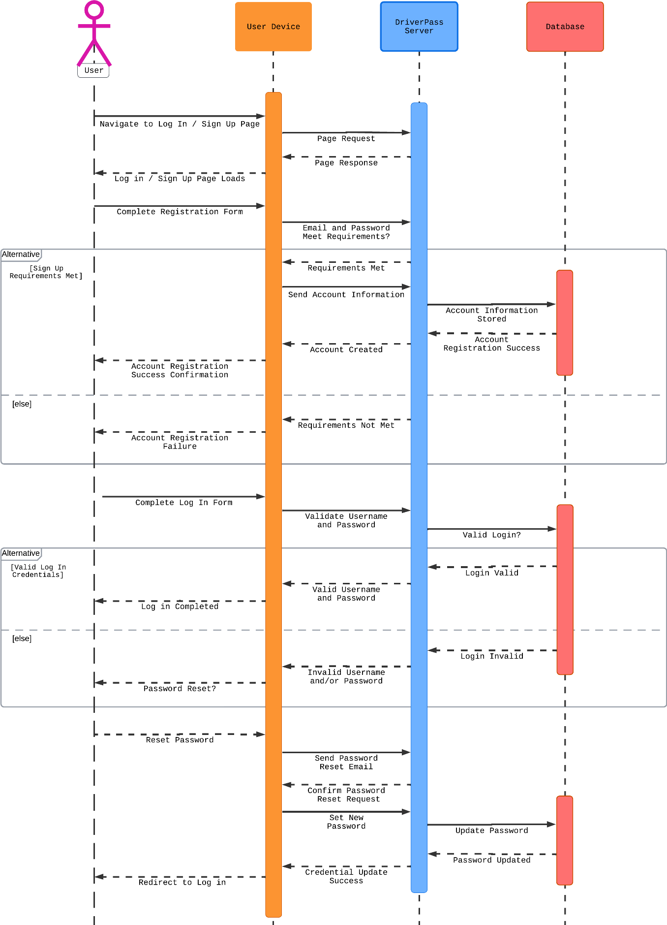

### UML Class Diagram

## Technical Requirements

Hardware:

* Cloud Server System serving multiple browser clients
* Internet Connection
* Device to access website
* Storage for database and website data
* Firewall to protect website ports

Software:

* Usage of a Windows Server, recommended for stability
* Deployment of an SQL database server
* Backup server for both website and database
* Implementation of a web-server, such as Apache
* Implementation of security software

Geographic:

* Ensure server is in a central location for better performance
* Ensure website can be accessed in the United States